**Assignment #4**

The data for this assignment is from the General Social Survey (GSS). The GSS collects data on modern American society in order to track and explain trends and constants in attitudes, behaviors, and attributes. The GSS is the best source for sociological and attitudinal trend data spanning the United States. It allows researchers to explore the structure and functioning of society in general along with the role played by relevant subgroups and to compare the United States to other nations.

This data examines different perspectives regarding national assistance with childcare. First, male and female perspectives were examined using an unpaired T test because the two groups were separate. A Wilcoxon rank sum test was done to ensure that the data was not skewed.

Analysis of males and females’ opinions on national assistance with childcare

|  |  |  |  |  |  |  |  |
| --- | --- | --- | --- | --- | --- | --- | --- |
| **Table 1. Male and Female Opinion on National Assistance with Childcare** | | | | | | |  |
|  |  |  |  |  |  |  |  |
| Variable |  | Mean | S.D. | Var. | Min. | Max. |  |
|  |  |  |  |  |  |  |  |
| Men |  | 1.51 | 0.627 | 0.38 | 1 | 3 |  |
| Women |  | 1.50 | 0.602 | 0.362 | 1 | 3 |  |
|  |  |  |  |  |  |  |  |
| Note: p-value for Wilcoxon rank sum test was not statistically significant p=0.05622 | | | | | | | |
| Note: p-value for t-test was not statistically significant p=0.061 | | | | | |  |  |
| Note: 95% confidence interval | | |  |  |  |  |  |

There was no significant different between how men and women viewed national assistance with childcare. Both groups were nearly identical. The data was found to be normally distributed, as well. The data followed the T test assumptions. There is a 95% chance that the means are true means.

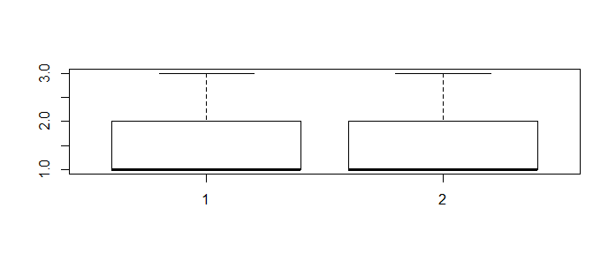

1= male, 2= female

Second, ANOVA was done to examine the opinions of different racial groups regarding national assistance with childcare. A Tukey test was done to see where exactly the difference occurred. There was a significant difference in opinion between Whites and Blacks on national assistance with childcare. No other significant differences were found. The data was also found to be normally distributed.

Analysis of various racial groups’ opinions on national assistance with childcare

|  |  |  |  |  |  |  |  |
| --- | --- | --- | --- | --- | --- | --- | --- |
| **Table. 2 Various Racial Groups' Opinions on National Assistance with Childcare** | | | | | | | |
|  |  |  |  |  |  |  |  |
| Variable |  | Mean | S.D. | Var. | Min. | Max. |  |
|  |  |  |  |  |  |  |  |
| White |  | 1.52 | 0.62 | 0.38 | 1 | 3 |  |
| Black |  | 1.33 | 0.55 | 0.3 | 1 | 3 |  |
| Other |  | 1.51 | 0.61 | 0.38 | 1 | 3 |  |
|  |  |  |  |  |  |  |  |
| Note: 95% confidence level | | |  |  |  |  |  |

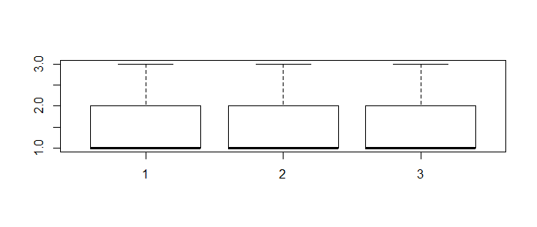

1=white, 2=black, 3=other